Query a list of **CITY** names from **STATION** for cities that have an even **ID** number. Print the results in any order, but exclude duplicates from the answer.  
The **STATION** table is described as follows:

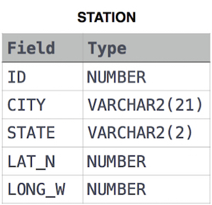

where **LAT_N** is the northern latitude and **LONG_W** is the western longitude.